(VI) How to apply the Viable System Model to get a fast design or diagnosis of an organization (Introduction-Part VI)
Pathologies related to System 2: Are my operating units governed by "Every man for himself!" Is chaos proliferating and reigning in our organization? Are we being overwhelmed by bureaucracy?

Jose Perez Rios
November 2023

1. I continue sharing some ideas taken from the Organizational Cybernetics (OC) field, with particular emphasis on the Viable System Model (VSM) that I think may be useful to any decision-taker in any organization.

The content of the OC approach, the details for its implementation and use can be consulted in the book:
Design and Diagnosis for Sustainable Organizations. The Viable System Method

https://link.springer.com/book/10.1007/978-3-642-22318-1

2. In this sixth general post, I will continue commenting on some of the most frequent pathologies in organizations. As I mentioned in previous posts, this knowledge is helpful to design them, so they are created free of them (healthy), or for diagnosing an existing organization. Once identified a pathology we can try to eliminate it.

In previous posts, I shared a short version of the first group of pathologies
(I. Structural Pathologies) and started to show some of the pathologies included in the second group: II. Functional Pathologies.

3. In the presentation I made for the Metaphorum Group in May 2022, I did show the three global maps with the more frequent organizational pathologies.

https://www.youtube.com/watch?v=62mRBzRDxHI

Organizational Pathologies (6)
J. Perez Rios

As I mentioned in previous posts, identifying a pathology is a prerequisite to prescribing any treatment for the diagnosed deficiency. With that aim, I prepared back in 2008 a taxonomy of "Organizational pathologies" that I am sharing. I classified the 26 ones I found widespread into three main families or groups.

The first group (I) includes pathologies related to organizations' structural design and how the organization copes with its total environmental complexity by creating the necessary sub-organizations. These I name Structural Pathologies.

The second group (II) includes pathologies related to the adequacy of the organizations (at all recursion levels) to the prescription made by the VSM about functional subsystems and their relations. These I call Functional Pathologies.

The third group (III) subsumes Information System and Communication Channel Pathologies.

In a previous posts, I shared a short version of the first group of pathologies:
I. Structural Pathologies) and started to show some of the pathologies included in the second group: II. Functional Pathologies.

The denominations used, as are System 5, System 2, etc., are typically used in the Beer's Viable System Model (VSM).

II. Functional Pathologies (6)

This group includes 17 pathologies related to each of the organizations that compose the entire organization. In each unit, one must check to see that all the essential functions (systems) necessary for the organization's viability exist and work adequately. This group includes the more frequent pathologies affecting each of the VSM functions (systems) and the whole organization (named as System 5, System 4, System 3, System 3*, Homeostat 4-3, System 2, and System 1). In this post I will mention the ones related to System 2.

Concerning the pathologies related to System 2 (in the VSM), some observations related to its role are convenient.

This system is intended to make the set of organizational units that comprise System 1 function harmoniously. These units may be related by production processes and supply chains or simply compete for the organization’s shared resources and even clients or suppliers, etc., which might lead to conflict as a result of each one attempting to achieve its own goals (the delivery of the assigned products or services). System 2 deals with such issues.

Pathologies related to System 2
Considering that System 2 is responsible for contributing to the harmonious behavior of the operational units in System 1, let's look at some pathologies typical of its poor design or functioning.

PII12. Disjointed Behavior Within System 1 (Each to His Own)
One sign of the dysfunction of System 2 (corporate and also specific for each of the individual operational units) is the existence of problems resulting from interactions among the elemental operational units constituting System 1. The following are indicators of this pathology: a lack of collaboration among the operational units, no solidarity in competition for shared resources, coordination problems among its activities, or the lack of a continuous process flow, when linked, from certain units to others. In general, signs that System 2 either does not exist or fails to work correctly occur when the operational units behave somewhat anarchically and when this can be dealt with solely by the direct intervention of System 3.

PII13. Authoritarian System 2 (Authoritarian Bureaucrats)
Another problem occasionally observed in association with System 2 is that the management of the operational units may perceive it as an authoritarian group attempting to impose specific working methods. In this case, System 2 will be unable to carry out its task successfully, as its purpose is to contribute to a better relationship among the operational units, providing them with means of coordination rather than orders. System 2’s image as being authoritarian detracts from its real nature (since only System 3 has authority over System 1) and may result in non-compliance with the actions that the processes designed by this system recommend. The example of traffic regulations for motorists (as an instance of System 2) helps us understand that such regulations are not orders but measures that facilitate and improve the safety of traffic flow on roads and motorways. These norms are usually welcomed by the general public, who regard them as contributing to their safety and not as orders they must obey.

For are detailed description of each pathology you may consult the book:
Design and Diagnosis for Sustainable Organizations. The Viable System Method
https://link.springer.com/book/10.1007/978-3-642-22318-1

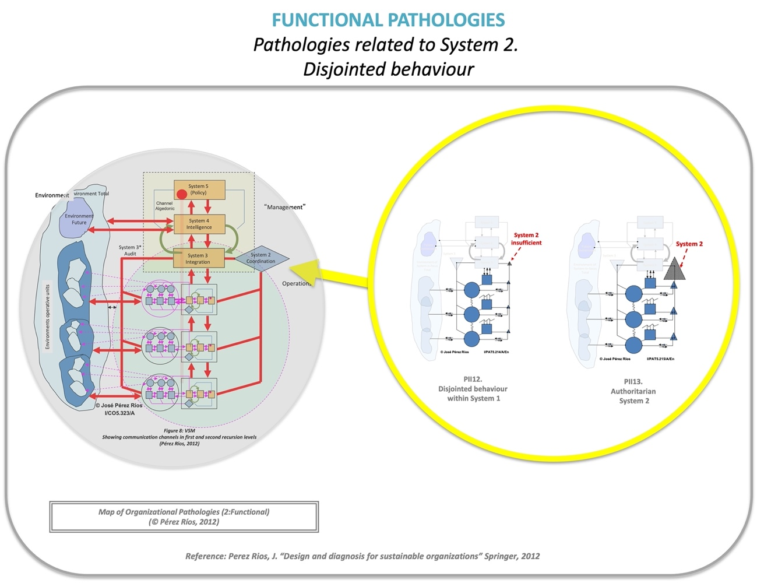
Functional Pathologies. Pathologies related to System 2.

